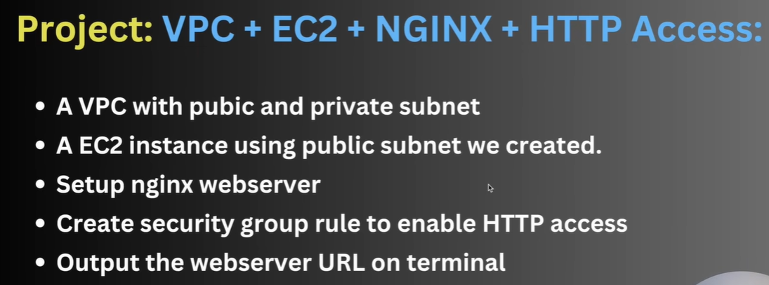
We created separate file for ec2.tf, main.tf, outpits.tf, providers.tf, vpc.tf etc to keep the code clean.
Entire data for this project can be access here
https://github.com/paulgitrepo/mprashant-terraform-configs/blob/main/aws-vpc-ec2-nginx/vpc.tf

how the nginx could be accessed in ec2, we are looking into this
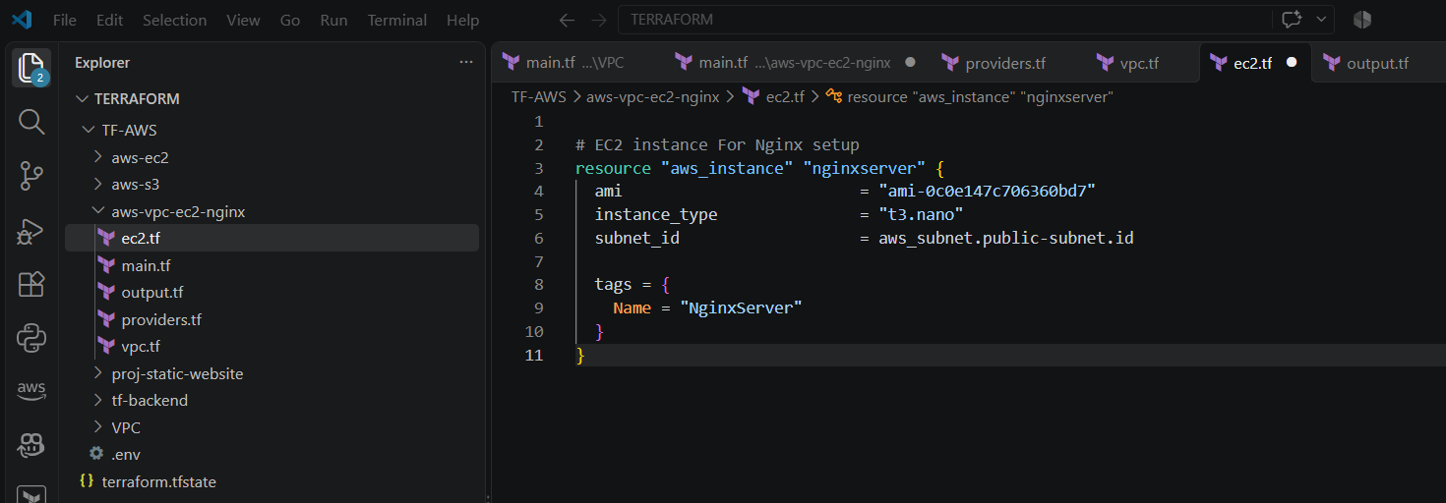

Now we have to configure security / firewall access and how to install nginx in this ec2.

- To install nginx we have to add the user_data in EC2
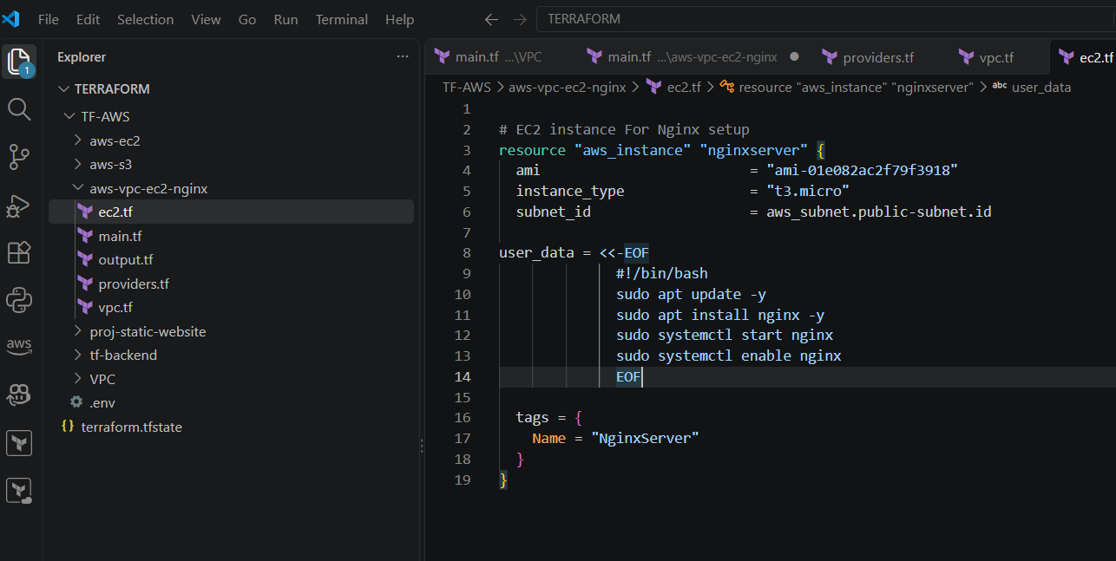

To access the nginx we will create a security group. We have created a different file for security group.

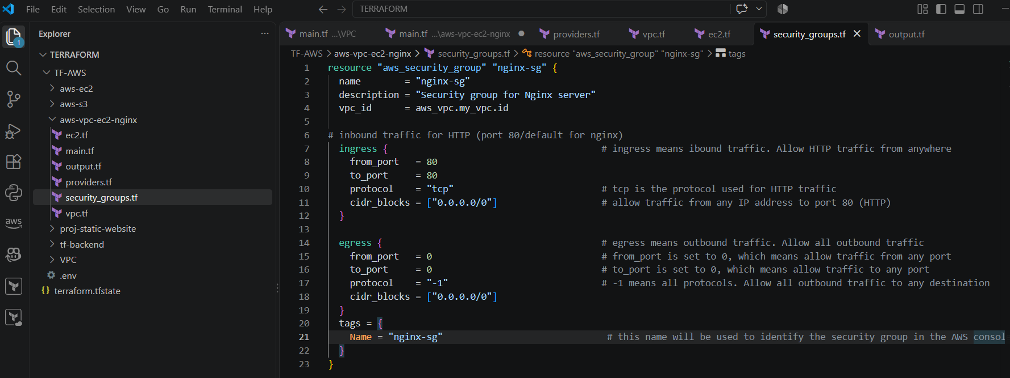

Rule is created, now how to use this rule.
We need to add security group and for accessing with browser we should have a public ip.

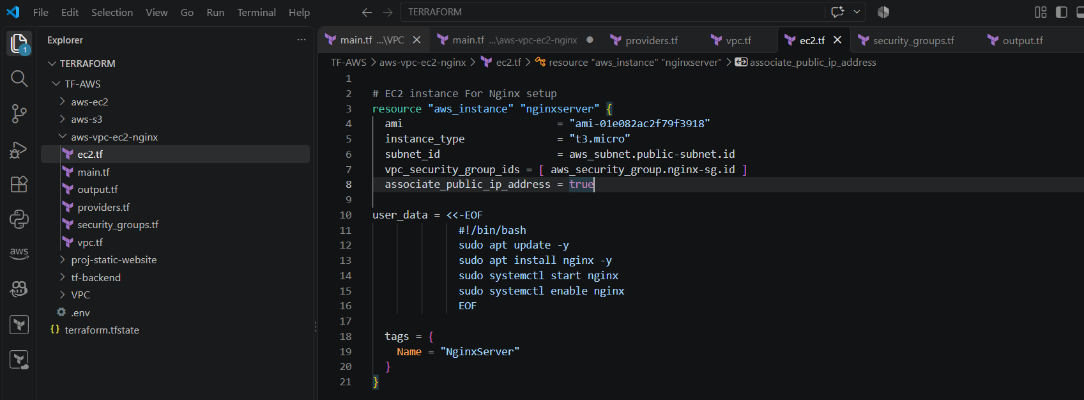

Now we will configure output
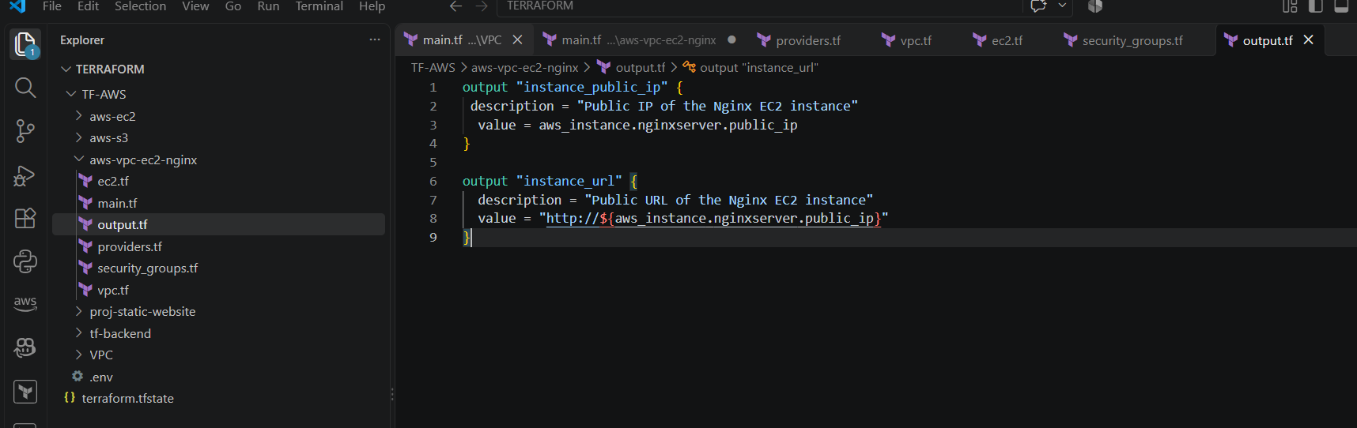

Now we are good to go
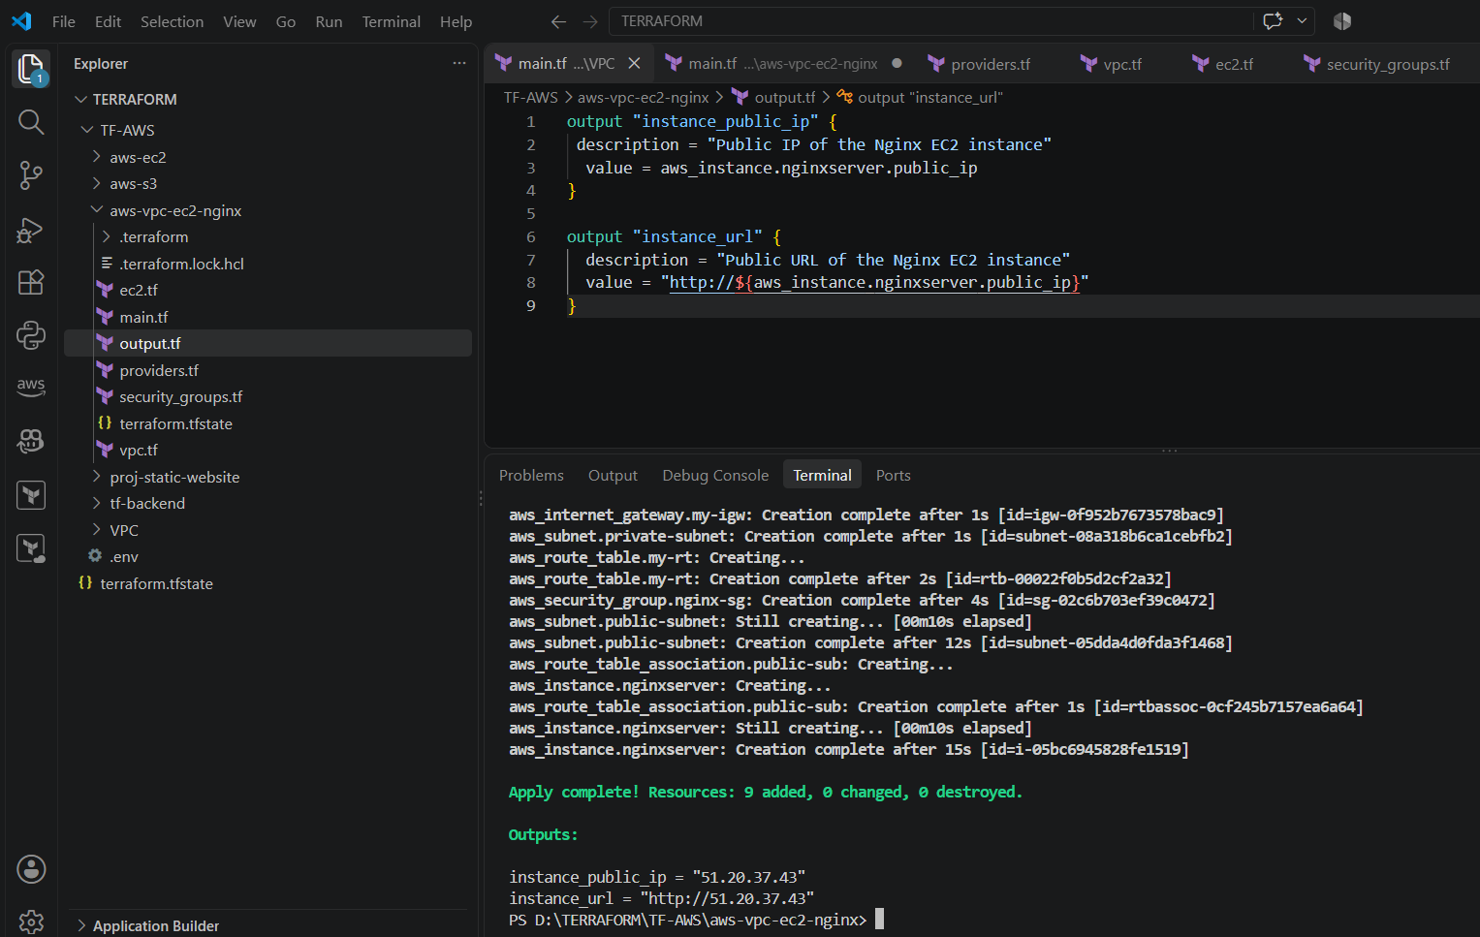

Instance created
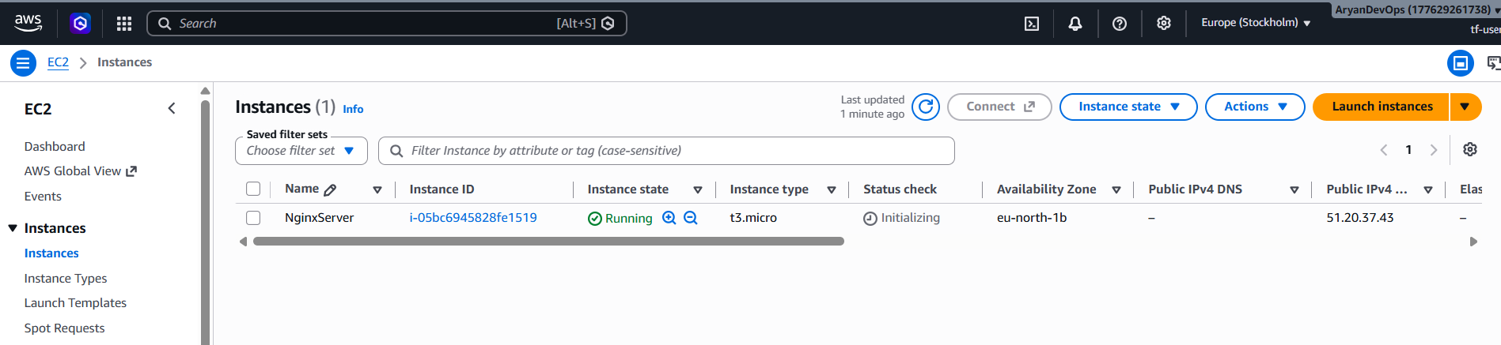

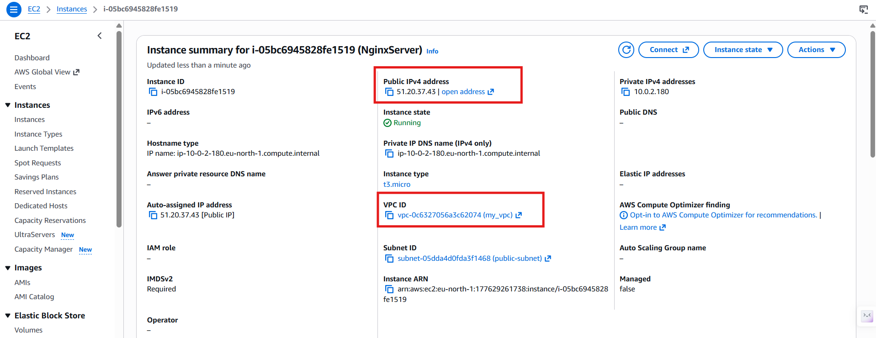

We have addon the security
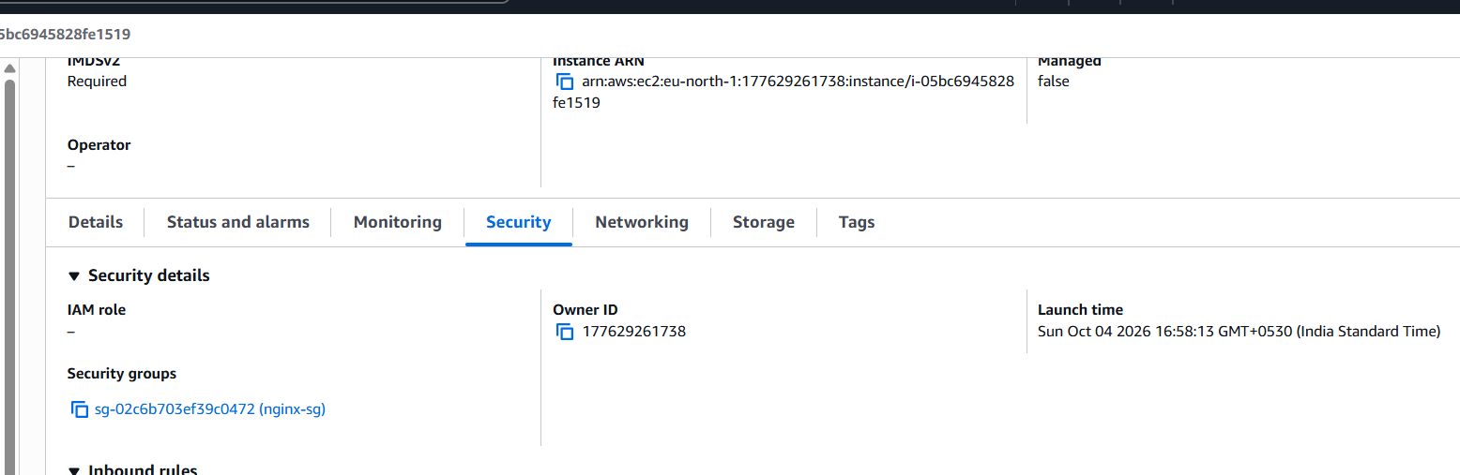

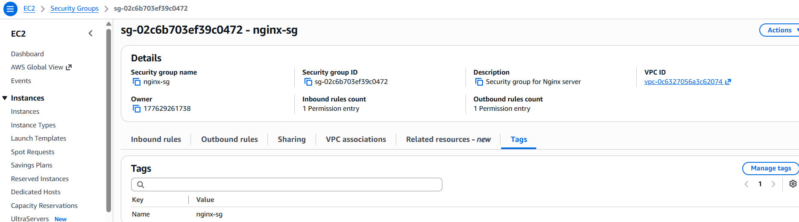
This is the same tag what we have given
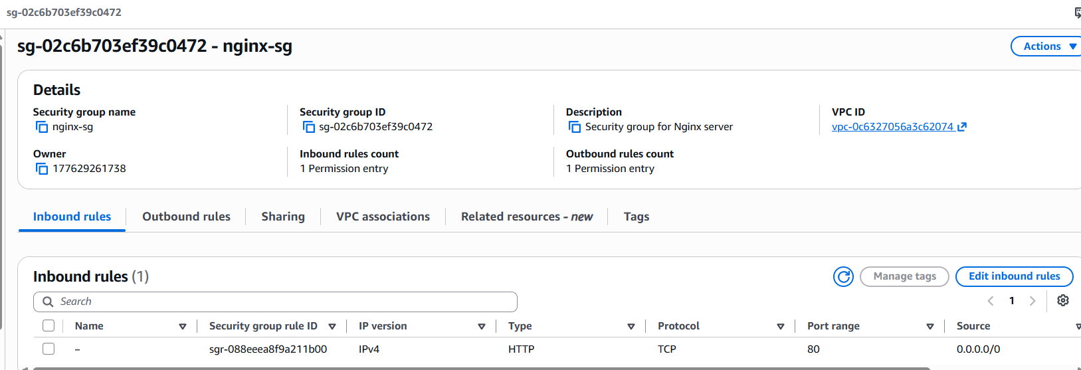

Inbound/outbound security group

Will past the url and check

